CHAPTER 4
RESULT AND DISCUSSION

Testing Environment

System Specification

Android Device
The application was tested and ran on the following Android device specifications.
Operating System | : | Android Marshmallow 6.0.1
CPU | : | Quad-core 2.5 GHz Krait 400
RAM | : | 3 GB
Internal Memory | : | 64 GB

Server
The prediction system is hosted on the Openshift Online Next Gen server. The server runs on Red Hat Enterprise Linux 7, and supports Apache Tomcat for Java environment integration.

Software
The following are the software used in this study.
- NetBeans IDE 8.2
- Android Studio 2.2.3
- Microsoft Excel 2016
- Tomcat Server 8.0
- R 3.3.2
- Gensim 0.13.3

Library
The following are the libraries that were used in this study.
- Twitter4j 4.0.4
- JExcel 2.6.12
- Weka 3.8.0
- Twokenizer
- XGBoost (via R)
- JodaTime 2.9.5
- JSastrawi 0.1
- Commons-lang 2.6
- Gson 2.3.1

Result

Data Distribution
Table 4.1 shows the data distribution for the training dataset with a total of 329 instances.

Table 4.1 Training Dataset Distribution
 | Open  ness | Extra  version | Emotional Stability | Conscien  tiousness | Agreeable  ness
High | 163 | 202 | 150 | 92 | 134
Low | 166 | 127 | 179 | 237 | 195

Table 4.2 shows the data distribution for the testing dataset with a total of 30 instances.

Table 4.2 Testing Dataset Distribution
 | Open  ness | Extra  version | Emotional Stability | Conscien  tiousness | Agreeable  ness
High | 16 | 24 | 21 | 16 | 19
Low | 14 | 6 | 9 | 14 | 11

Selected Features for Prediction System
The features selected for this study consists of 2 main parts: user behavior and user tweets.
There are a total of 12 user behavior features, namely:
- Tweet count
- Followers count
- Following count
- Favorites count
- Retweets count
- Retweeted count
- Quote count
- Mentions count
- Replies count
- Hashtag count
- URL count
- Date-time average

There are 2 types of features extracted from user tweets, which are n-gram features and LDA topic count features. Each n-gram feature represents a term, while each LDA feature represent a topic generated by the LDA algorithm.

Evaluation: Comparison Between Selected Features, Methods and Algorithms
Evaluation is done by crossing various features, methods, and algorithms with 10-fold cross validation data and testing dataset of 30 instances. The following list are scenarios adopted for the evaluation.
- Minimum occurrence
Minimum occurrence refers to the minimum number of times a certain n-gram occurs in the dataset.
The minimum occurrence value used in the evaluation is minimum occurrence = 1 and minimum occurrence = 2.
- Weighting scheme
This refers to the weighting scheme used to represent each feature’s value.
The weighting scheme used in the evaluation is Boolean and raw frequency. The raw frequency value for each feature is normalized to prevent skewed weight values caused by different number of tweets from each user.

- Usage of LDA topic feature
This method refers to whether the LDA topic feature is used on the system.
Therefore, the comparison for this scenario is use LDA topic feature and don’t use LDA topic feature.
- Stop words omission
This method refers to whether stop words are omitted from the n-gram features.
Therefore, the comparison for this scenario is don’t omit (include stop words) and omit (don’t include stop words).
The following list are the various scenarios at crossing features, methods, and algorithms.
- Minimum occurrence=1, Boolean weighting, use LDA topic features, and omit stop words.
- Minimum occurrence=1, Boolean weighting, use LDA topic features, and don’t omit stop words.
- Minimum occurrence=1, Boolean weighting, don’t use LDA topic features, omit stop words.
- Minimum occurrence=1, Boolean weighting, don’t use LDA topic features, don’t omit stop words.
- Minimum occurrence=1, raw frequency weighting, use LDA topic features, and omit stop words.
- Minimum occurrence=1, raw frequency weighting, use LDA topic features, and don’t omit stop words.
- Minimum occurrence=1, raw frequency weighting, don’t use LDA topic features, and omit stop words.
- Minimum occurrence=1, raw frequency weighting, don’t use LDA topic features, and don’t omit stop words.
- Minimum occurrence=2, Boolean weighting, use LDA topic features, and omit stop words.
- Minimum occurrence=2, Boolean weighting, use LDA topic features, and don’t omit stop words.
- Minimum occurrence=2, Boolean weighting, don’t use LDA topic features, and omit stop words.
Table 4.3 SMO Evaluation with 10-Fold Cross Validation
No | min |  | Weighting |  | LDA |  | Stopword |  | A | C | ES | E | O |  | AVG
No | 1 | 2 | Boolean | TF | LDA | non-LDA | omit | not omit
1 |  |  |  |  |  |  |  |  | 63.8298% | 62.0061% | 54.4073% | 71.4286% |  | 58.0547% | 61.9453%
2 |  |  |  |  |  |  |  |  | 64.4377% | 62.9179% | 54.4073% | 69.6049% |  | 60.7903% | 62.4316%
3 |  |  |  |  |  |  |  |  | 64.1337% | 62.0061% | 55.3191% | 71.1246% |  | 60.4863% | 62.6140%
4 |  |  |  |  |  |  |  |  | 64.1337% | 61.7021% | 54.1033% | 71.1246% |  | 62.3100% | 62.6747%
5 |  |  |  |  |  |  |  |  | 74.1641% | 73.8602% | 75.6839% | 79.9392% |  | 77.2036% | 76.1702%
6 |  |  |  |  |  |  |  |  | 74.4681% | 74.4681% | 75.6839% | 78.7234% |  | 77.8116% | 76.2310%
7 |  |  |  |  |  |  |  |  | 64.4377% | 60.4863% | 56.5350% | 72.3404% |  | 61.7021% | 63.1003%
8 |  |  |  |  |  |  |  |  | 65.9574% | 60.7903% | 55.0152% | 72.3404% |  | 61.7021% | 63.1611%
9 |  |  |  |  |  |  |  |  | 60.1824% | 56.2310% | 54.7112% | 64.4377% |  | 55.6231% | 58.2371%
10 |  |  |  |  |  |  |  |  | 63.2219% | 53.1915% | 52.5836% | 65.9574% |  | 52.5836% | 57.5076%
11 |  |  |  |  |  |  |  |  | 61.0942% | 57.7508% | 56.2310% | 66.5653% |  | 55.9271% | 59.5137%
12 |  |  |  |  |  |  |  |  | 61.0942% | 52.8875% | 51.9757% | 68.3891% |  | 52.8875% | 57.4468%
13 |  |  |  |  |  |  |  |  | 75.6839% | 72.6444% | 76.8997% | 77.8116% |  | 77.8116% | 76.1702%
14 |  |  |  |  |  |  |  |  | 76.2918% | 68.6930% | 78.7234% | 77.2036% |  | 77.2036% | 75.6231%
15 |  |  |  |  |  |  |  |  | 59.8784% | 56.2310% | 55.3191% | 73.5562% |  | 57.7508% | 60.5471%
16 |  |  |  |  |  |  |  |  | 64.1337% | 52.5836% | 53.7994% | 72.0365% |  | 57.7508% | 60.0608%

Legend:
= selected actions for each scenario

- Minimum occurrence=2, Boolean weighting, don’t use LDA topic features, and don’t omit stop words.
- Minimum occurrence=2, raw frequency weighting, use LDA topic features, omit stop words.
- Minimum occurrence=2, raw frequency weighting, use LDA topic features, don’t omit stop words.
- Minimum occurrence=2, raw frequency weighting, don’t use LDA topic features, and omit stop words.
- Minimum occurrence=2, raw frequency weighting, don’t use LDA topic features, and don’t omit stop words.

SMO (Support Vector Machine)

SMO (Support Vector Machine) with 10-Fold Cross Validation
Table 4.3 shows the accuracy of the system using SMO’s Support Vector Machine when tested with the scenarios listed above (Section 4.2) evaluated with 10-fold cross validation.
Table 4.3 shows that SMO’s Support Vector Machine performed best in scenario 6 (minimum occurrence=1, raw frequency weighting scheme, use LDA topic features, don’t omit stop words). Under said scenario, SMO’s Support Vector Machine was able to reach an average accuracy of 76.2310%.
It has similar accuracies with scenario 5 (minimum occurrence=1, raw frequency weighting scheme, use LDA topic features, omit stop words) and 13 (minimum occurrence=2, raw frequency weighting scheme, use LDA topic features, omit stop words). Both scenarios achieved an average accuracy of 76.1702%.
Closing in behind from scenario 5 and 13’s accuracy is scenario 14 (minimum occurrence=2, raw frequency weighting scheme, use LDA topic features, don’t omit stop words), with an average accuracy of 75.6231%.
Table 4.4 SMO Evaluation on Testing Data
No | min |  | Weighting |  | LDA |  | Stopword |  | A | C | ES | E | O | AVG
No | 1 | 2 | Boolean | TF | LDA | non-LDA | omit | not omit
1 |  |  |  |  |  |  |  |  | 70% | 50% | 53.33% | 56.67% | 46.67% | 55.3340%
2 |  |  |  |  |  |  |  |  | 76.67% | 53% | 40% | 53.33% | 43.33% | 53.2660%
3 |  |  |  |  |  |  |  |  | 70% | 60% | 53.33% | 53.33% | 46.67% | 56.6660%
4 |  |  |  |  |  |  |  |  | 73.33% | 56.67% | 40% | 53.33% | 43.33% | 53.3320%
5 |  |  |  |  |  |  |  |  | 63.33% | 60% | 60% | 73.33% | 53.33% | 61.9980%
6 |  |  |  |  |  |  |  |  | 90% | 63.33% | 56.67% | 70% | 53.33% | 66.6660%
7 |  |  |  |  |  |  |  |  | 66.67% | 66.67% | 60% | 80% | 56.67% | 66.0020%
8 |  |  |  |  |  |  |  |  | 73.33% | 70% | 60% | 76.67% | 50% | 66.0000%
9 |  |  |  |  |  |  |  |  | 60% | 60% | 76.67% | 60% | 46.67% | 60.6680%
10 |  |  |  |  |  |  |  |  | 56.67% | 53.33% | 66.67% | 70% | 66.67% | 62.6680%
11 |  |  |  |  |  |  |  |  | 60% | 60% | 70% | 63.33% | 50% | 60.6666%
12 |  |  |  |  |  |  |  |  | 53.33% | 60% | 60% | 70% | 66.67% | 62.0000%
13 |  |  |  |  |  |  |  |  | 80% | 73.33% | 83.33% | 90% | 73.33% | 79.9980%
14 |  |  |  |  |  |  |  |  | 76.67% | 76.67% | 83.33% | 90% | 73.33% | 80.0000%
15 |  |  |  |  |  |  |  |  | 63.33% | 56.67% | 70% | 80% | 50% | 64.0000%
16 |  |  |  |  |  |  |  |  | 66.67% | 60% | 73.33% | 83.33% | 53.33% | 67.3320%

Legend:
= selected actions for each scenario

These 4 scenarios have 2 things in common: raw frequency weighting scheme and usage of LDA topic features. This may be indicators that raw frequency weighting and LDA topic features contribute significantly to the prediction result.
As for individual personality trait prediction, the highest accuracy achieved was 79.9392. This was achieved in predicting the Extraversion trait, in scenario 5 (minimum occurrence=1, weighting scheme=raw frequency, use LDA topic features, and omit stop words).

SMO (Support Vector Machine) with Testing Dataset of 30 Instances
Table 4.4 shows the accuracy of the system using SMO’s Support Vector Machine when tested with the scenarios listed above (Section 4.2) evaluated with testing dataset of 30 instances.
Table 4.4 shows that the SMO’s Support Vector Machine achieved highest average accuracy of 80% in scenario 14 (minimum occurrence=2, raw frequency weighting scheme, use LDA topic features, don’t omit stop words).
The second highest accuracy was achieved in scenario 13 (minimum occurrence=2, raw frequency weighting scheme, use LDA topic features, omit stop words) with 79.9980%.
Both results have similar scenarios where minimum occurrence=2, weighting scheme is raw frequency and LDA topic features are used. When compared to the results from Table 4.3 (SMO’s Support Vector Machine Evaluation with 10-Fold Cross Validation), all scenarios with high accuracy so far involves the raw frequency weighting scheme and usage of LDA topic features.
For individual personality trait prediction, the highest accuracy was achieved on Agreeableness trait scenario 6 (minimum occurrence=1, raw frequency weighting scheme, use LDA topic features, don’t omit stop words) and Extraversion trait scenarios 13 (minimum
Table 4.5 XGBoost Evaluation with 10-Fold Cross Validation
No | min |  | Weighting |  | LDA |  | Stopword |  | A | C | ES | E | O | AVG
No | 1 | 2 | Boolean | TF | LDA | non-LDA | omit | not omit
1 |  |  |  |  |  |  |  |  | 53.50% | 62.95% | 54.41% | 74.46% | 58.33% | 60.7330%
2 |  |  |  |  |  |  |  |  | 57.71% | 59.26% | 51.35% | 74.44% | 56.81% | 59.9148%
3 |  |  |  |  |  |  |  |  | 56.85% | 59.87% | 49.85% | 74.45% | 60.79% | 60.3598%
4 |  |  |  |  |  |  |  |  | 53.48% | 61.09% | 50.43% | 73.85% | 56.19% | 59.0076%
5 |  |  |  |  |  |  |  |  | 97.58% | 98.48% | 98.79% | 97.27% | 96.96% | 97.8163%
6 |  |  |  |  |  |  |  |  | 97.87% | 98.48% | 98.79% | 97.58% | 97.26% | 97.9962%
7 |  |  |  |  |  |  |  |  | 57.76% | 59.91% | 58.39% | 77.16% | 60.16% | 62.6742%
8 |  |  |  |  |  |  |  |  | 65.96% | 61.37% | 55.02% | 75.96% | 61.10% | 63.8807%
9 |  |  |  |  |  |  |  |  | 57.16% | 61.09% | 51.03% | 72.92% | 59.55% | 60.3485%
10 |  |  |  |  |  |  |  |  | 57.77% | 59.55% | 52.28% | 74.43% | 62.28% | 61.2633%
11 |  |  |  |  |  |  |  |  | 58.67% | 59.86% | 52.60% | 73.23% | 59.86% | 60.8447%
12 |  |  |  |  |  |  |  |  | 56.26% | 58.64% | 50.70% | 74.44% | 58.01% | 59.6098%
13 |  |  |  |  |  |  |  |  | 95.13% | 95.45% | 95.45% | 94.54% | 93.91% | 94.8939%
14 |  |  |  |  |  |  |  |  | 95.45% | 95.75% | 96.36% | 94.84% | 93.30% | 95.1402%
15 |  |  |  |  |  |  |  |  | 59.55% | 55.91% | 59.28% | 75.06% | 60.77% | 62.1136%
16 |  |  |  |  |  |  |  |  | 61.38% | 59.83% | 48.64% | 74.74% | 56.83% | 60.2841%

Legend:
= selected actions for each scenario

occurrence=2, raw frequency weighting scheme, use LDA topic features, omit stop words) and 14 (minimum occurrence=2, raw frequency weighting scheme, use LDA topic features, don’t omit stop words), with an accuracy of 90%.

XGBoost (Gradient Tree Boosting)

XGBoost’s Gradient Tree Boositng with 10-Fold Cross Validation
Table 4.5 shows the accuracy of the system using XGBoost’s Gradient Tree Boosting when tested with the scenarios listed above (Section 4.2) evaluated with 10-fold cross validation.
Table 4.5 shows that XGBoost’s Gradient Boosting Tree achieved the best average accuracy in scenario 6 (minimum occurrence=1, raw frequency weighting, use LDA topic features, don’t omit stop words) with an accuracy of 97.9962%
Results in scenario 5 (minimum occurrence=1, raw frequency weighting scheme, use LDA topic features, omit stop words), 13 (minimum occurrence=2, raw frequency weighting scheme, use LDA topic features, omit stop words), and 14 (minimum occurrence=2, raw frequency weighting scheme, use LDA topic features, don’t omit stop words) are similar to scenario 6. Scenario 5 achieved an accuracy of 97.8163%, scenario 13 with accuracy of 94.8939%, and scenario 14 with accuracy of 95.1402%.
Once again, all the scenarios with high accuracies mentioned so far involve the raw frequency weighting scheme, and using LDA topic features.
Highest individual personality trait accuracy was achieved in scenario 5 (minimum occurrence=1, raw frequency weighting scheme, use LDA topic features, and omit stop words) and scenario 6 (minimum occurrence=1, raw frequency weighting scheme, use LDA
Table 4.6 XGBoost Evaluation with Testing Data
No | min |  | Weighting |  | LDA |  | Stopword |  | A | C | ES | E | O | AVG
No | 1 | 2 | Boolean | TF | LDA | non-LDA | omit | not omit
1 |  |  |  |  |  |  |  |  | 73.33% | 60.00% | 43.33% | 73.33% | 56.67% | 61.3333%
2 |  |  |  |  |  |  |  |  | 53.33% | 70.00% | 46.67% | 73.33% | 60.00% | 60.6667%
3 |  |  |  |  |  |  |  |  | 63.33% | 70.00% | 56.67% | 76.67% | 43.33% | 62.0000%
4 |  |  |  |  |  |  |  |  | 66.67% | 73.33% | 40.00% | 66.67% | 53.33% | 60.0000%
5 |  |  |  |  |  |  |  |  | 36.67% | 43.33% | 30.00% | 20.00% | 46.67% | 35.3333%
6 |  |  |  |  |  |  |  |  | 100.00% | 43.33% | 30.00% | 20.00% | 46.67% | 48.0000%
7 |  |  |  |  |  |  |  |  | 66.67% | 60.00% | 43.33% | 70.00% | 46.67% | 57.3333%
8 |  |  |  |  |  |  |  |  | 70.00% | 50.00% | 43.33% | 80.00% | 60.00% | 60.6667%
9 |  |  |  |  |  |  |  |  | 50.00% | 60.00% | 56.67% | 80.00% | 43.33% | 58.0000%
10 |  |  |  |  |  |  |  |  | 56.67% | 53.33% | 53.33% | 80.00% | 50.00% | 58.6660%
11 |  |  |  |  |  |  |  |  | 60.00% | 70.00% | 63.33% | 83.33% | 56.67% | 66.6660%
12 |  |  |  |  |  |  |  |  | 53.33% | 56.67% | 50.00% | 73.33% | 50.00% | 56.6660%
13 |  |  |  |  |  |  |  |  | 96.67% | 96.67% | 100.00% | 100.00% | 96.67% | 98.0020%
14 |  |  |  |  |  |  |  |  | 93.33% | 96.67% | 96.67% | 96.67% | 100.00% | 96.6680%
15 |  |  |  |  |  |  |  |  | 63.33% | 63.33% | 56.67% | 76.67% | 46.67% | 61.3340%
16 |  |  |  |  |  |  |  |  | 46.67% | 50.00% | 70.00% | 80.00% | 56.67% | 60.6680%

Legend:
= selected actions for each scenario

topic features, and don’t omit stop words) on the Emotional Stability personality trait.

XGBoost’s Gradient Tree Boosting with Testing Data of 30 Instances
Table 4.6 shows the accuracy of the system using XGBoost’s Gradient Boosting Tree when tested with the scenarios listed above (Section 4.2) evaluated with testing dataset of 30 instances.
Table 4.6 shows that XGBoost’s Gradient Boosting Tree achieved its highest accuracy in scenario 13 (minimum occurrence=2, raw frequency weighting scheme, use LDA topics, and omit stop words) and 14 (minimum occurrence=2, raw frequency weighting scheme, use LDA topics, and don’t omit stop words). Scenario 13 resulted in an accuracy of 98.0020%, whereas scenario 14 resulted in 96.6680%.
Results from Table 4.6 also show that the highest accuracies are achieved by using the raw frequency weighting scheme and using LDA topics. This is consistent with the results from Tables 4.3, 4.4, and 4.5.
For individual personality trait predictions, the system achieved highest accuracy on Agreeableness trait scenario 6 (minimum occurrence=1, raw frequency weighting scheme, use LDA topic features, and don’t omit stop words), Emotional Stability and Extraversion scenario 13 (minimum occurrence=2, raw frequency weighting scheme, use LDA topic features, omit stop words) and Openness scenario 14 (minimum occurrence=2, raw frequency weighting scheme, use LDA topic features, don’t omit stop words), with 100% accuracy.

Android Application User Interface
Figures 4.1 to 4.8 are the final application user interface for the Android application.

 | 
Figure 4.1 Home screen of Android application.

The home screen consists of 3 main components: a text field, a button, and an app icon.
- Username text field
The username text field allows the user to input a Twitter username to evaluate the inputted user’s personality trait.
- “Prediksi Kepribadian” button
This component needs to be pressed in order to start the predicting process based on the user’s input.
- App icon
The app icon component allows the user to access the application’s navigation drawer. The user can choose which screen to navigate to with the navigation drawer. The app icon which triggers the navigation drawer appears in each screen except when the application is working on the personality prediction.
 | 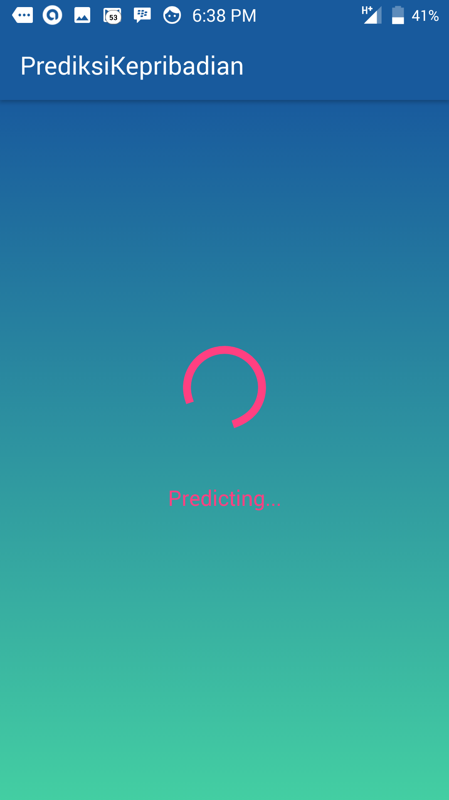
Figure 4.2 Loading screen of Android application.

Figure 4.2 shows the display on the screen when the application is loading. The picture on the left shows the state of the application when obtaining Twitter data, while the picture on the right shows the state of the application when waiting for the prediction result from the server.


Figure 4.3 Navigation drawer of Android application.

Figure 4.3 shows the appearance of the application’s navigation drawer. The navigation drawer appears from the left of the screen upon clicking the app icon located on the top left of the application. The navigation drawer consists of 4 navigations: prediction, information, contact and exit.
- Prediction
The prediction navigation navigates the user to the home screen, where the user can input a username.
- Information
The information navigation navigates the user to the information screen, where the user can view the description of each trait, the characteristics of an individual with low level personality trait, and the characteristics of an individual with high level personality trait.

- Contact
Upon pressing the contact navigation, the user is navigated to the contact screen which displays the information of authors of this study.
- Exit
Pressing the exit navigation will close the application.

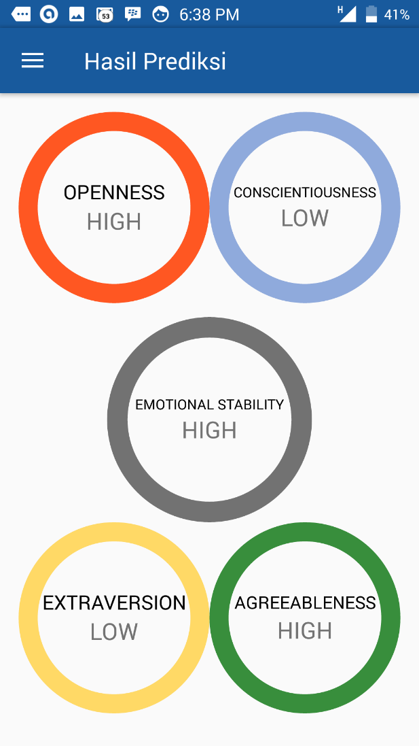
Figure 4.4 Result screen of Android application.

Figure 4.4 shows the result screen which appears once the personality prediction result has been returned from the server to the Android application. The screen displays 5 results, each representing one personality trait. For each personality trait, the application displays whether an individual has a high or low level of a personality trait.

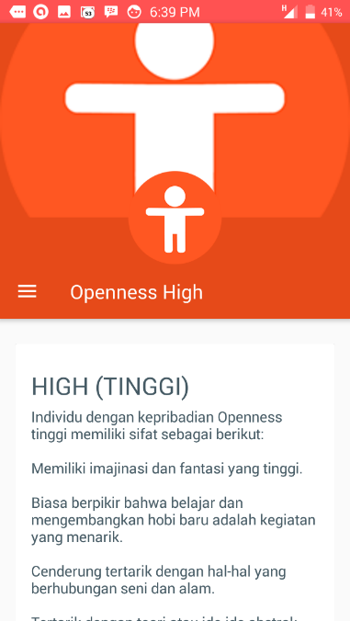 | 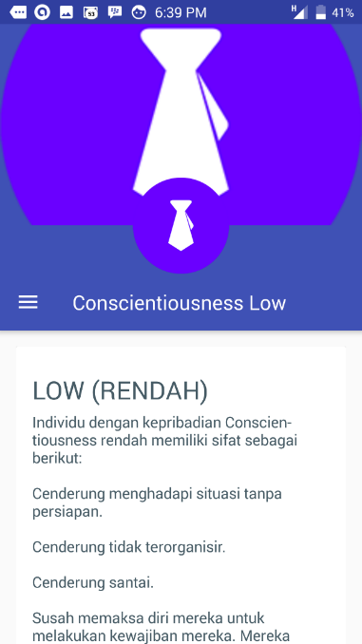
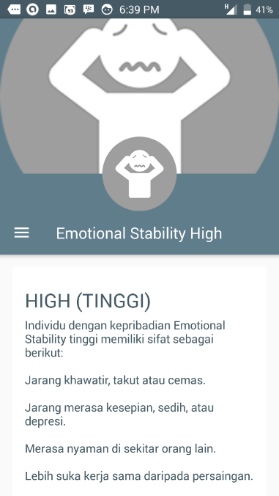 | 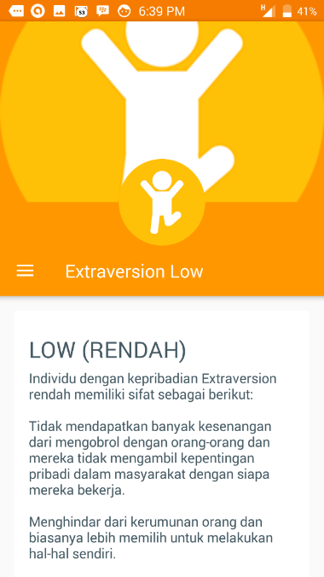

Figure 4.5 Result description screen of Android application.
Figure 4.5 shows the result description screen of the application. Each personality trait has a separate screen displaying the characteristics of the personality trait result. This screen can be accessed upon clicking the result of each personality trait.

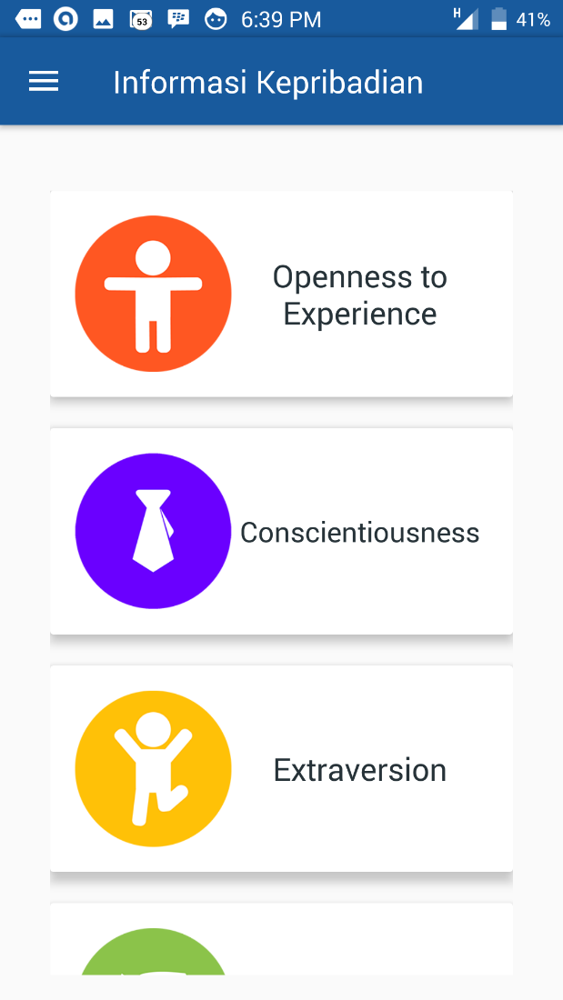 | 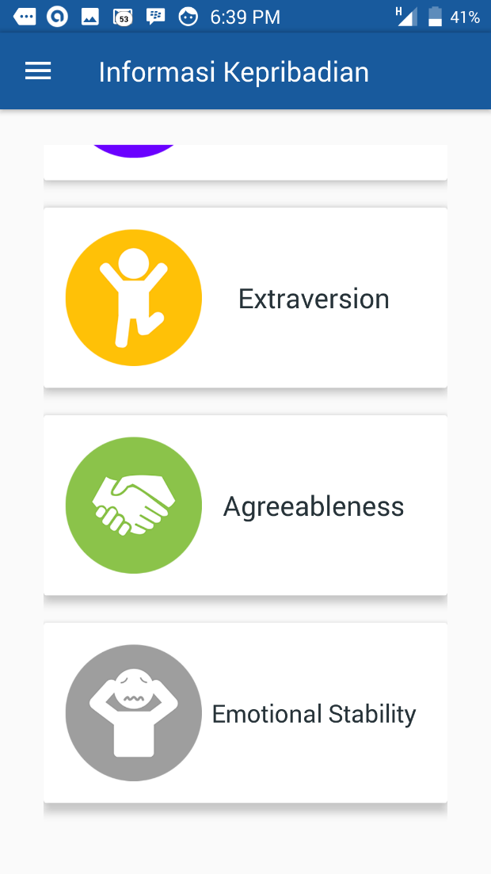
Figure 4.6 Information screen of Android application.

Figure 4.6 shows the menu of the information screen. This screen allows the user to choose which personality trait information to view.

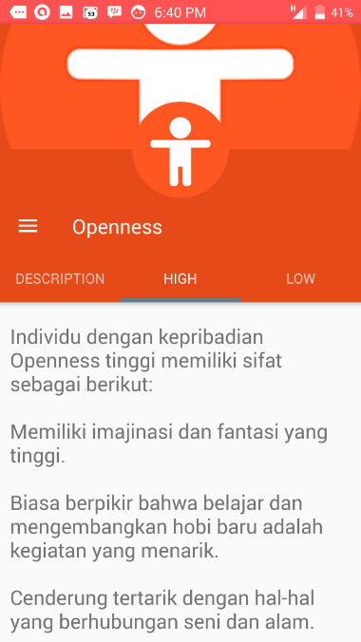 | 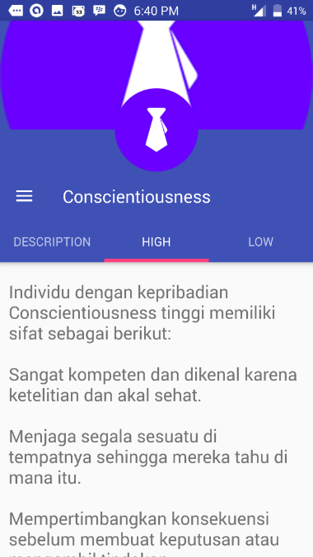
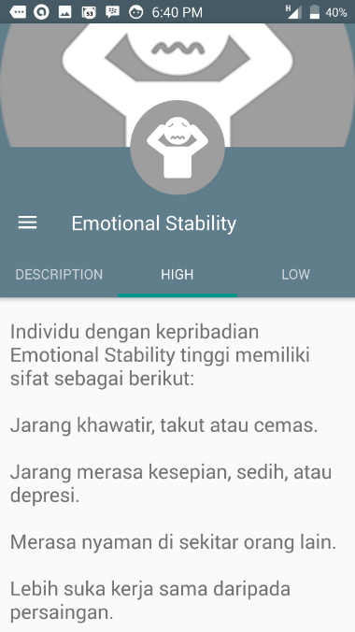 | 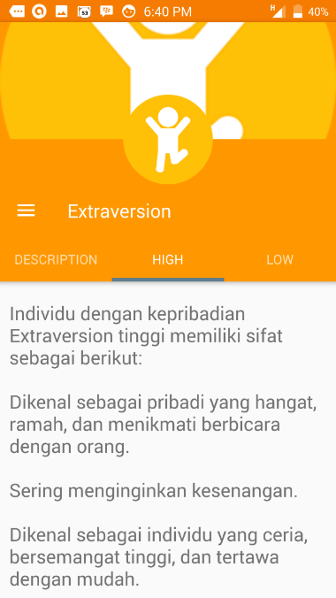

Figure 4.7 Personality trait information screen of Android application.
The screen that appears upon pressing on each personality trait is shown in Figure 4.7. Each screen contains 3 tabs: description tab, high tab, and low tab.
- Description tab
The description tab contains the basic information of each personality trait.
- High tab
The high tab contains a list of characteristics which describe an individual with a high level of a certain personality trait.
- Low tab
The low tab contains a list of characteristics which describe an individual with a low level of a certain personality trait.


Figure 4.8 Contact information screen of Android application.

The contact information screen shown in Figure 4.8 presents the list of authors in charge of the application’s development.

Evaluation

Subjective Evaluation
Evaluation is done through an interview session. 10 people volunteered to participate in an interview to evaluate this study’s prediction system. Participants are active Twitter users who use Bahasa Indonesia as their main tweeting language. Interview was conducted in Bahasa Indonesia through several methods such as face-to-face meeting and phone call. The difference in methods is due to the inability to meet up with respondents from outside of Jakarta.
Participants were prompted to fill out an online form before the interview session. This online form serves as proof that they agree to participate in the evaluation. The form is also distributed to find out demographic information regarding the participants.
The following are the demographic information from users who participated in the evaluation.

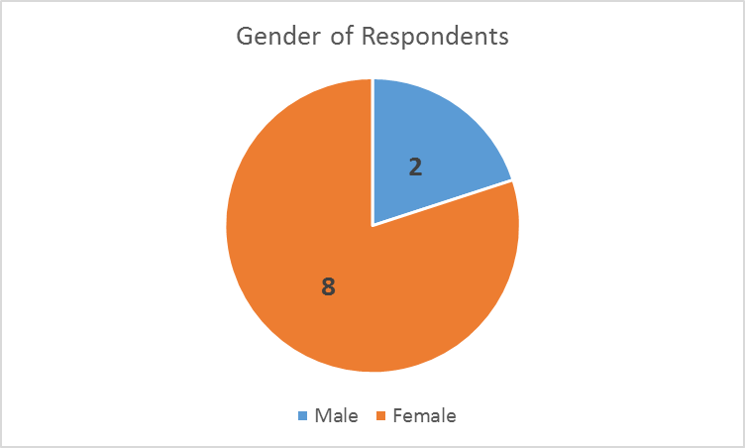
Figure 4.9 Pie Chart of Respondent’s Gender

Figure 4.9 shows the proportion of our respondent’s gender.
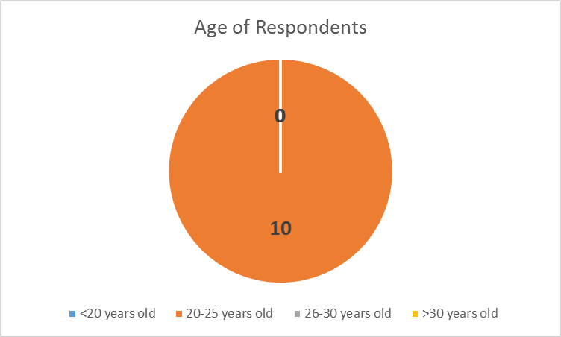
Figure 4.10 Pie Chart of Respondent’s Age

Figure 4.10 shows the age demographic proportion of the respondents.
The interview starts when the user has filled out the online form. Each user is asked a set of questions about their thoughts on their personality prediction result.
For a list of question and answers from each participant, see Appendix 2.
The following are the main points obtained from the interview from 10 respondents.
- Most respondents (8 out of 10) think that the prediction system is quick enough.
- Most respondents think that the Openness trait prediction is accurate, scoring an average of 8.5 out of 10.
- Most respondents think that the Conscientiousness trait prediction is moderately accurate, scoring an average of 7.65 out of 10.
- Most respondents think that the Extraversion trait prediction is moderately accurate, scoring an average of 7.1 out of 10.
- Most respondents think that the Agreeableness trait prediction isn’t that accurate, scoring an average of 6.25 out of 10.
- Most respondents think that the Emotional Stability trait prediction is moderately accurate, scoring an average of 7.25 out of 10.
- Most respondents feel that the system is already accurate. Besides the system, they also made remarks regarding the user interface which probably could be improved further.
Table 4.7 shows the quantitative scoring for each personality trait from each respondent.

Table 4.7 Quantitative Scoring per Trait per Respondent
Respondent | Openness | Conscientiousness | Extraversion | Agreeableness | Emotional Stability
Respondent 1 | 9 | 7 | 3 | 6 | 4
Respondent 2 | 8 | 9 | 4 | 3 | 7
Respondent 3 | 10 | 8 | 8 | 10 | 10
Respondent 4 | 6 | 8.5 | 10 | 10 | 7.5
Respondent 5 | 8 | 8 | 9 | 4 | 6
Respondent 6 | 10 | 7 | 10 | 1 | 7
Respondent 7 | 9 | 8 | 9 | 2 | 8
Respondent 8 | 8 | 10 | 9 | 10 | 7
Respondent 9 | 9 | 4 | 4 | 9 | 9
Respondent 10 | 8 | 7 | 5 | 7.5 | 7
Average score | 8.5 | 7.65 | 7.1 | 6.25 | 7.25

Objective Evaluation
The following section provides an objective evaluation which compares the current study’s results with results from previous personality prediction literatures. The evaluation is done with the following 3 literatures which have been previously reviewed in Chapter 2, and reported the same evaluation measures with the current study. The evaluation measure considered for this study is the accuracy of the personality prediction system per personality trait.

Bahasa Indonesia Personality Prediction

Personality Classification Based on Twitter Text Using Naïve Bayes, KNN and SVM
A previous literature by Pratama & Sarno (2015) had attempted to build a personality prediction from Bahasa Indonesia social media text for Twitter. They built their prediction model through user tweets and did a comparison between 3 classifiers: Multinomial Naïve Bayes, K-Nearest Neighbors, and Support Vector Machine.
Table 4.8 shows the difference between current study and Pratama & Sarno’s study.

Table 4.8 Differences Between Pratama & Sarno’s Study and Current Study
Differences |  | PRATAMA, SARNO (2015)’S STUDY | CURRENT STUDY
Multinomial Naïve Bayes algorithm |  | ✓
K-Nearest Neighbor algorithm |  | ✓
Support Vector Machine algorithm |  | ✓ | ✓
Gradient Boosting Tree algorithm |  |  | ✓
User behavior features |  |  | ✓
User tweet features
 | n-gram features | ✓ | ✓
 | LDA topic features |  | ✓
 | Stop words omission | ✓ | ✓
 | Stemming | ✓
 | Boolean weighting |  | ✓
 | Raw frequency weighting |  | ✓
 | TF-IDF weighting | ✓

Objective evaluation is done by comparing the best accuracies obtained by each classifier for each personality trait from both the current study and Pratama & Sarno’s study. Both evaluations are done with 10-fold cross validation.

Table 4.9 Table of Best Accuracies per Personality Trait and Algorithm from Pratama & Sarno’s Study and Current Study
 | Pratama, Sarno (2015)’s Study |  |  | Current Study
 | Algorithms Used |  |  | Algorithms Used
 | Multinomial Naïve Bayes | K-Nearest Neighbors | SVM | SVM | GBT
Openness | 63.21 ± 1.84 | 60.71 ± 2.48 | 62.95 ± 1.2 | 77.8116 | 97.26
Conscien  tiousness | 58.67 ± 2.1 | 61.08 ± 3.19 | 60.35 ± 1.38 | 74.4681 | 98.48
Extraver  sion | 51.5 ± 2.02 | 52.87 ± 2.03 | 53.21 ± 2.17 | 78.7234 | 97.58
Emotional Stability | 54.63 ± 2.01 | 54.0 ± 1.83 | 54.2 ± 2.14 | 75.6839 | 98.79
Agreeable  ness | 72.29 ± 2.13 | 62.83 ± 2.07 | 65.75 ± 1.69 | 74.4681 | 97.87

Table 4.9 shows the best accuracies obtained from both studies per personality trait and algorithm. As seen from the table, the Support Vector Machine (SVM) and Gradient Boosting Tree (GBT) classifiers from our study’s result outperformed all algorithms used in Pratama & Sarno’s study. Results from the Support Vector Machine algorithm differ, so the difference in accuracies may be due to the differences in the usage of text features.

English Personality Prediction

“The Big Five Traits” Personality Prediction System from Twitter Data (Sistem Prediksi Kepribadian “The Big Five Traits” Dari Data Twitter)
One of the several attempts to build a personality prediction system on Twitter is conducted by Wijaya, Prasetia, Febrianto, & Suhartono. Their study focuses on building a personality prediction system based on English tweets. The prediction system is compared on a Support Vector Machine, Naïve Bayes, and ZeroR classifier.

Table 4.10 Differences Between Wijaya, Prasetia, Febrianto, & Suhartono’s Study and Current Study
Differences |  | WIJAYA, PRASETIA, FEBRIANTO, & SUHARTONO (2016)’S STUDY | CURRENT STUDY
Naïve Bayes algorithm |  | ✓
ZeroR algorithm |  | ✓
Support Vector Machine algorithm |  | ✓ | ✓
Gradient Boosting Tree algorithm |  |  | ✓
User behavior features |  | ✓ | ✓
Category-based features (LIWC) |  | ✓
User tweet features
 | n-gram features | ✓ | ✓
 | LDA topic features |  | ✓
 | Stop words omission |  | ✓
 | Boolean weighting | ✓ | ✓
 | Raw frequency weighting | ✓ | ✓

Objective evaluation is done by comparing the highest accuracies from classifying each personality trait in both studies. The algorithm evaluation from Wijaya, Prasetia, Febrianto, & Suhartono’s study only covers Support Vector Machine as only said algorithm’s results are provided. Table 4.11 shows the list of said accuracies.

Table 4.11 Table of Accuracies per Personality Trait and Algorithm from Wijaya, Prasetia, Febrianto, & Suhartono’s Study and Current Study
 | Wijaya, Prasetia, Febrianto, & Suhartono (2016)’s Study | Current Study
 | Algorithms Used | Algorithms Used
 | SVM | SVM | GBT
Openness | 61.436 | 77.8116 | 97.26
Conscientiousness | 80.876 | 74.4681 | 98.48
Extraversion | 64.3938 | 78.7234 | 97.58
Emotional Stability | 77.8957 | 75.6839 | 98.79
Agreeableness | 70.5351 | 74.4681 | 97.87

As seen in Table 4.11, the current study’s Support Vector Machine algorithm outperformed the previous study’s result on the Openness, Extraversion, and Agreeableness trait, whereas it’s still unable to improve the results on Conscientiousness and Emotional Stability trait. Results from the Gradient Boosting Tree on the other hand, managed to outperform results from all traits.
The reason for the difference in accuracy is mainly because of the difference in dataset, methodology, and algorithm. Wijaya, Prasetia, Febrianto, & Suhartono’s study is based on an English dataset, while the current study’s is based on Bahasa Indonesia dataset. The previous study’s methodology is also based on a category-based analysis (LIWC), while the current study’s is based on a word-based analysis. Lastly, the usage of Gradient Boosting Tree may play a part in the accuracy. As mentioned in Chapter 2, several literatures utilizing XGBoost’s Gradient Boosting Tree have reported results which outperform other algorithms.

Large Scale Personality Classification of Bloggers
Another study attempted to build a personality prediction system from Blogger social media text which was conducted by Iacobelli, Gill, Nowson, & Oberlander. Unlike Wijaya, Prasetia, Febrianto, & Suhartono’s study which was based on a category-based analysis, this study uses a word-based analysis. The classifiers applied to this study are the Support Vector Machine and ZeroR algorithm. Table 4.12 shows the difference between the current study and Iacobelli, Gill, Nowson, & Oberlander’s study.

Table 4.12 Differences Between Iacobelli, Gill, Nowson, & Oberlander’s Study and Current Study
Differences |  | IACOBELLI, GILL, NOWSON, & OBERLANDER (2011)’S STUDY | CURRENT STUDY
ZeroR algorithm |  | ✓
Support Vector Machine algorithm |  | ✓ | ✓
Gradient Boosting Tree algorithm |  |  | ✓
User behavior features |  |  | ✓
User tweet features
 | n-gram features | ✓ | ✓
 | LDA topic features |  | ✓
 | Stop words omission | ✓ | ✓
 | Boolean weighting | ✓ | ✓
 | Raw frequency weighting |  | ✓
 | TF-IDF weighting | ✓

Objective evaluation is done by comparing the highest accuracies in classifying each personality trait. The following objective evaluation only covers the results from Support Vector Machine as it is the only reported result from the study. Reported accuracies are presented in Table 4.13.

Table 4.13 Table of Accuracies per Personality Trait and Algorithm from Between Iacobelli, Gill, Nowson, & Oberlander’s Study and Current Study
 | Iacobelli, Gill, Nowson, & Oberlander (2011)’s Study | Current Study
 | Algorithms Used | Algorithms Used
 | SVM | SVM | GBT
Openness | 70.51 | 77.8116 | 97.26
Conscientiousness | 71.68 | 74.4681 | 98.48
Extraversion | 84.36 | 78.7234 | 97.58
Emotional Stability | 78.31 | 75.6839 | 98.79
Agreeableness | 79.18 | 74.4681 | 97.87

As seen on Table 4.13, the current study’s Support Vector Machine classifier outperforms result from Iacobelli, Gill, Nowson, & Oberlander’s study on the Openness and Conscientiousness trait. The current study still was unable to improve the results for Extraversion, Emotional Stability, and Agreeableness. When utilizing the Gradient Boosting Tree on the other hand, it outperforms results from all traits.
The difference in accuracies may be caused by 2 reasons. The first is because the current study utilizes LDA topic features, which have proven to influence the accuracy significantly. The absence of this feature in Iacobelli Gill, Nowson, & Oberlander’s study may have affected the accuracy. Finally, the results may differ because of the difference in algorithm. As mentioned before in Chapter 2, recent literatures have reported increased accuracy when utilizing the XGBoost Gradient Boosting Tree algorithm.

